SR UNIVERSITY
AI ASSISTED CODING
LAB TEST – 03
L.ABHINAV
2503A51L19
BATCH-19
Set E5
Q1:
Scenario: In the domain of Agriculture, a company is facing a challenge related to web
frontend development.
Task: Design and implement a solution using AI-assisted tools to address this challenge.
Include code, explanation of AI integration, and test results.
Deliverables: Source code, explanation, and output screenshots
CODE:
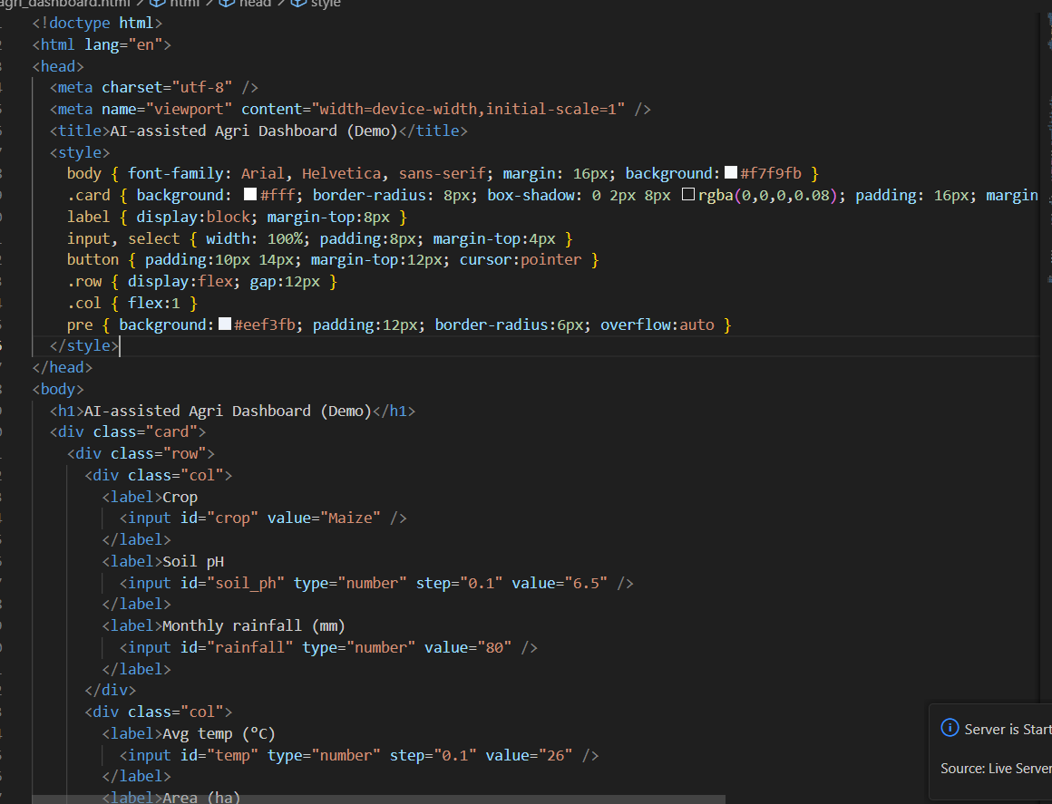
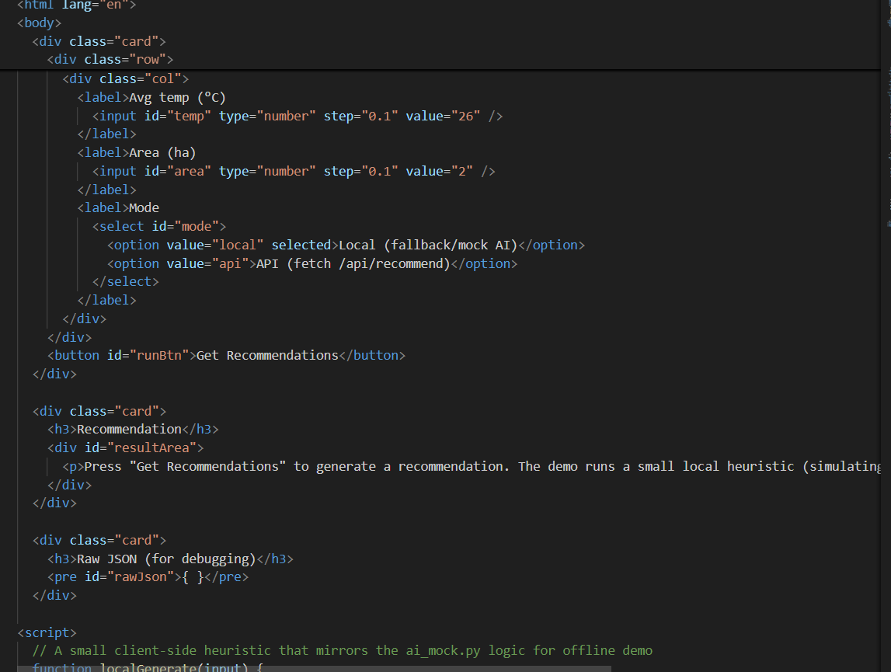
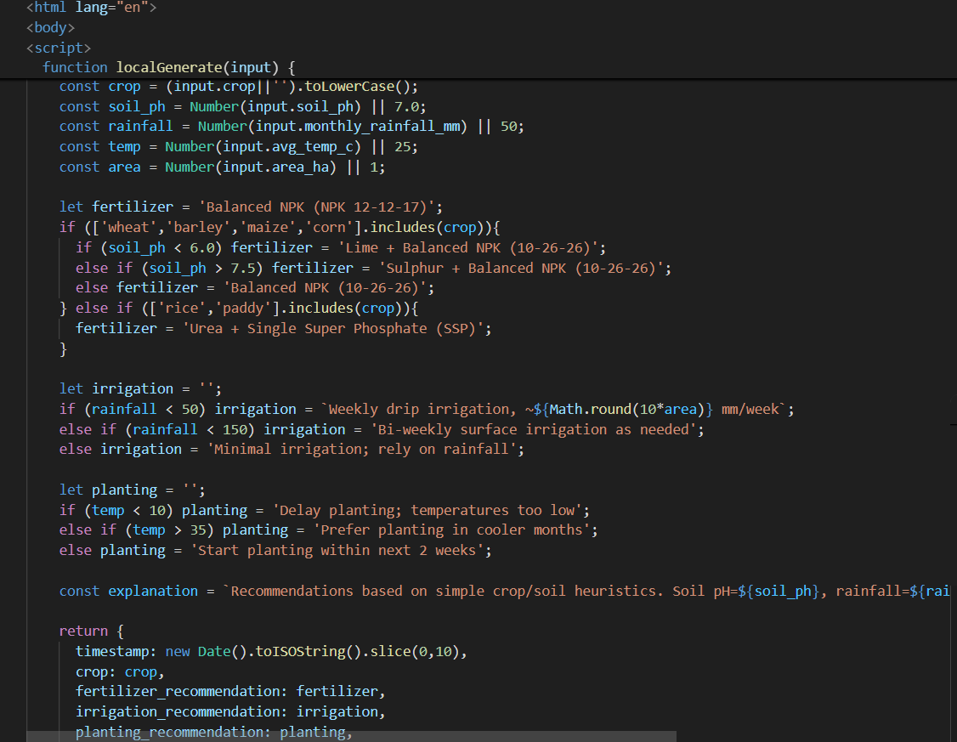
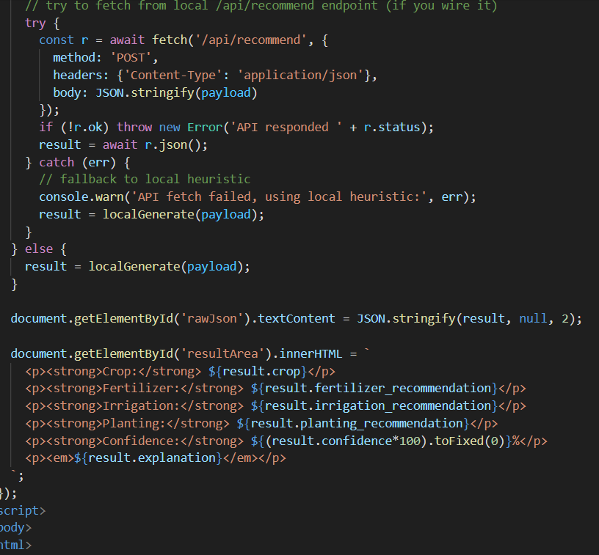
OUTPUT:
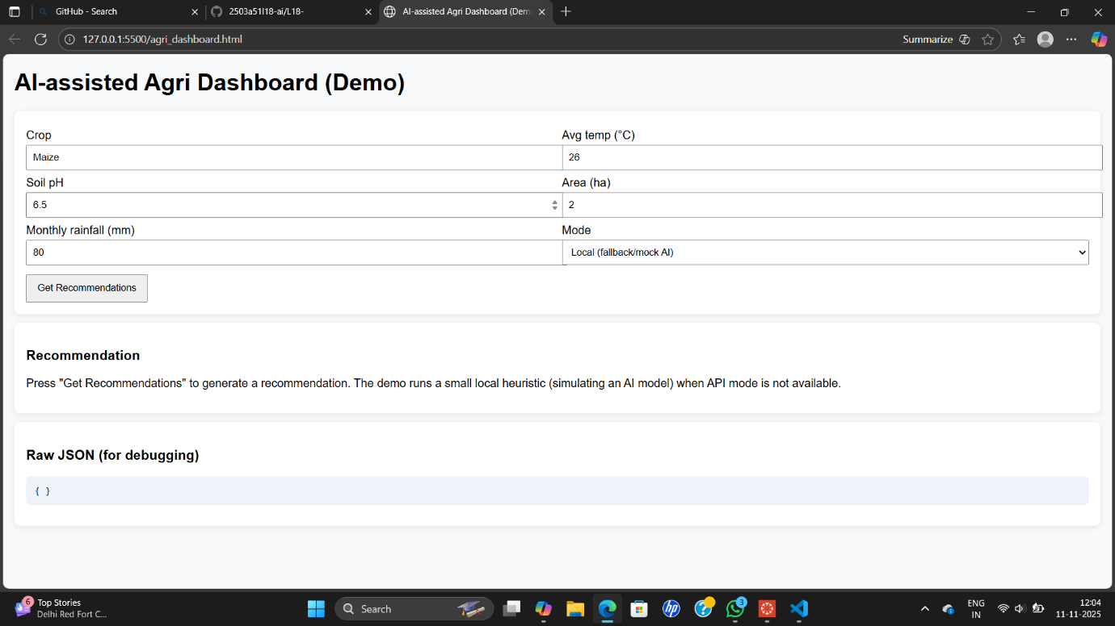

Q2:
Scenario: In the domain of E-commerce, a company is facing a challenge related to code
refactoring.
Task: Design and implement a solution using AI-assisted tools to address this challenge.
Include code, explanation of AI integration, and test results.
Deliverables: Source code, explanation, and output screenshots.
CODE:
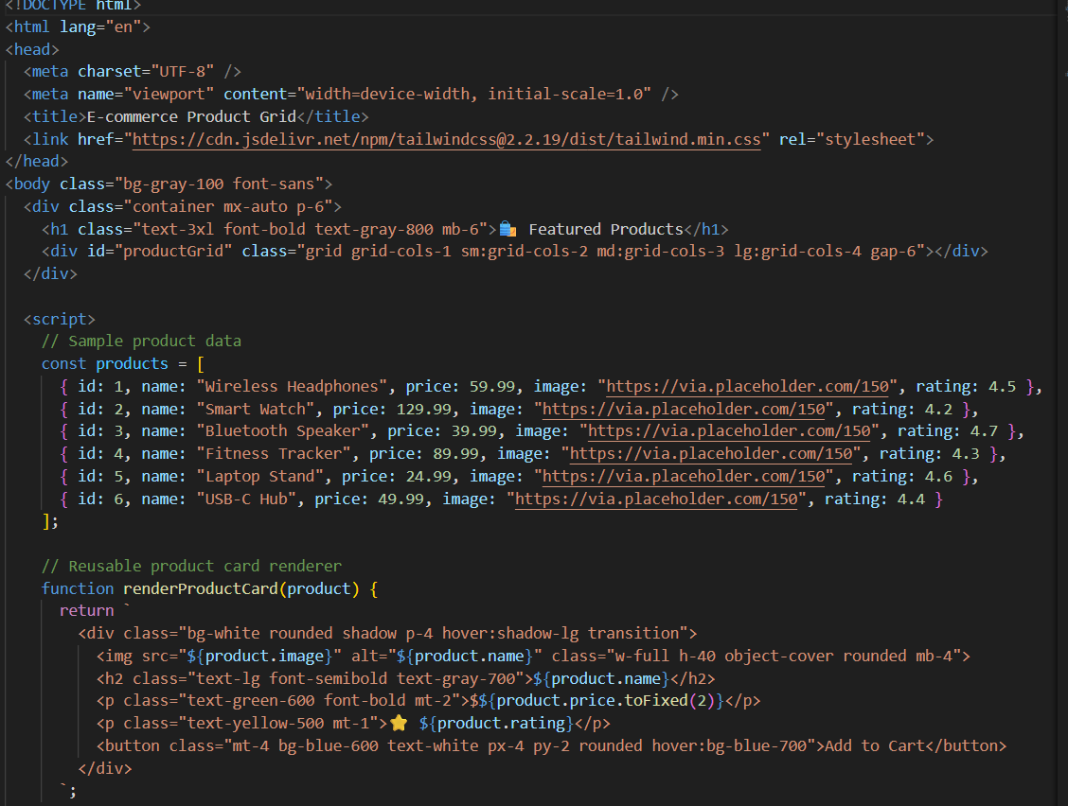
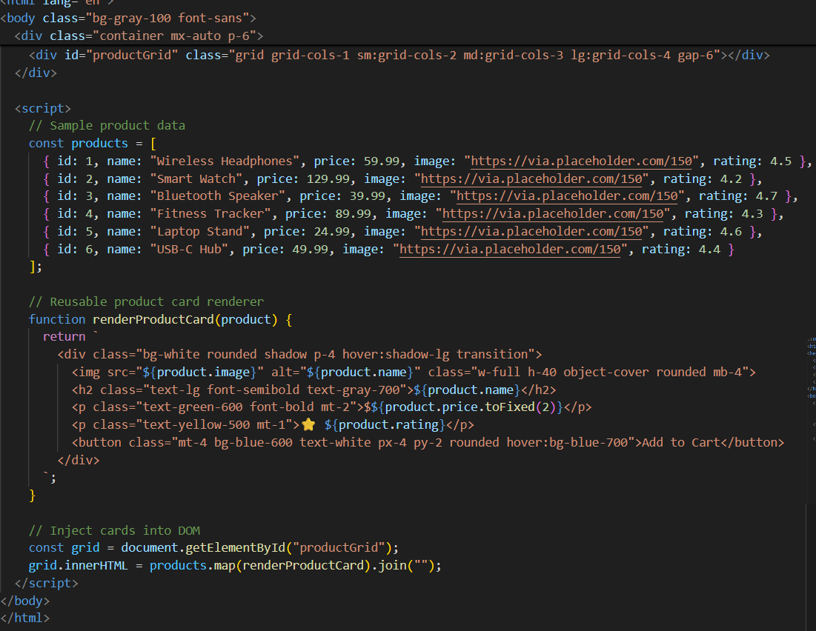
OUTPUT:
